

Padification SDD

Date: 2017-07-13

Version: 0.4.2

McKenzie College SWTS2102

1. Revision History

|  |  |  |  |
| --- | --- | --- | --- |
| Date | Author | Ver. | Revision Notes |
| 2017-06-19 | William Gale | 0.1 | Heading layout for document. Integration of SQL TCP/IP configuration and a quick development tool outline prototype. |
| 2017-06-21 | Elie Godbout | 0.2 | Updated contents of Appendices; Added Visual aid & enhanced the process information. Added a List of Images to SDD. |
| 2017-06-23 | Elie Godbout | 0.3 | Added Steps for creation of the PADification database and prerequisites for the process in Appendices. |
| 2017-06-26 | Zachary Blue | 0.4 | Added images for downloading of OBDC and SQLCMD |
| 2017-06-26 | Elie Godbout | 0.4.1 | Updated the Steps for installations of ODBC and SQLCMD in Appendices. |
| 2017-07-13 | Elie Godbout | 0.4.2 | Added tools to the development tool outline, updated steps for create the PADification database and added steps to delete the PADification database. Added contents to section 2.8 Interface viewpoint. |

1. Table of Contents

I. Revision History 2

II. Table of Contents 3

III. List of Images 4

1 Development Tool Outline 5

2 Design Viewpoints 5

2.1 Introduction 5

2.2 Context Viewpoint 5

2.2.1 User Use Case Diagrams 5

2.3 Composition Viewpoint 5

2.3.1 Deployment Diagram 5

2.4 Logical Viewpoint 5

2.5 Dependency Viewpoint 5

2.6 Information Viewpoint 5

2.6.1 Information gathering 5

2.7 Patterns Viewpoint 5

2.8 Interface Viewpoint 6

2.8.1 Login screen 6

2.8.2 Account creation screen 7

2.8.3 Home screen 8

2.8.4 Player collection 9

2.8.5 Edit Monster screen 10

2.8.6 Monster Book screen 11

2.8.7 My Teams screen 12

2.8.8 Edit team screen 2

2.8.9 Community screen 3

2.8.10 Team Ranking screen 3

2.8.11 Account information screen 3

2.9 Structure Viewpoint 3

2.10 Interactions Viewpoint 3

2.11 State Dynamics Viewpoint 3

2.12 Algorithm Viewpoint 3

2.13 Resources 3

3 Appendices 3

3.1 Tool Configuration 3

3.1.1 Configure MSSQL DB for Remote Connections. 3

3.1.2 Create the Database from .bat files 15

1. List of Images

Figure 2.8‑1: PADification Login screen 7

Figure 2.8‑2: PADification account creation screen 8

Figure 2.8‑3: PADification Home screen 9

Figure 2.8‑4: PADification Player collection screen 10

Figure 2.8‑5: PADification Edit monster screen 11

Figure 2.8‑6: PADification Monster book screen 12

Figure 2.8‑7: PADification My teams screen 13

Figure 2.8‑8: PADification Edit team screen 2

Figure 2.8‑9: PADification Account screen 3

Figure 3.1‑1: Open SQL server Configuration 4

Figure 3.1‑2: SQL server configuration; Protocols for MSSQLSERVER 4

Figure 3.1‑3: SQL server Configuration Enable TCP/TP 4

Figure 3.1‑4: SQL server Configuration Server services 5

Figure 3.1‑5: SQL server Configuration restart MSSQLSERVER 5

Figure 3.1‑6: MSSQL SMS New log in 6

Figure 3.1‑7: MSSQL SMS New log in SQL Server Authentication 6

Figure 3.1‑8: MSSQL SMS New log in name/password/Enforce Password Policy 6

Figure 3.1‑9: MSSQL SMS New log in Server Roles 7

Figure 3.1‑10: MSSQL SMS New log in Server Roles SysAdmin 7

Figure 3.1‑11: MSSQL SMS Server Properties 8

Figure 3.1‑12: MSSQL SMS Server properties Security 8

Figure 3.1‑13: MSSQL SMS Server Properties SQL Server and Windows Authentication mode 9

Figure 3.1‑14: Windows Firewall 9

Figure 3.1‑15: Windows Firewall Advanced settings 10

Figure 3.1‑16: Windows Firewall Inbound Rules 10

Figure 3.1‑17: Windows Firewall Inbound Rules/New Rules 10

Figure 3.1‑18: Windows Firewall Inbound Rules/New Rules/Port 11

Figure 3.1‑19: Windows Firewall Inbound Rules/New Rules/Specified local port 11

Figure 3.1‑20: Windows Firewall Inbound Rules/New Rules/Allow connection 12

Figure 3.1‑21: Windows Firewall Inbound Rules/New Rules/Profile 12

Figure 3.1‑22: Windows Firewall Inbound Rules/New Rules/Name 12

Figure 3.1‑23: Windows Firewall Outbound Rules 13

Figure 3.1‑24: Windows Firewall Outbound Rules/New Rules 13

Figure 3.1‑25: Windows Firewall Outbound Rules/New Rules/Port 13

Figure 3.1‑26: Windows Firewall Outbound Rules/New Rules/Specific remote ports 14

Figure 3.1‑27: Windows Firewall Outbound Rules/New Rules/Allow connection 14

Figure 3.1‑28: Windows Firewall Outbound Rules/New Rules/Profile 14

Figure 3.1‑29: Windows Firewall Outbound Rules/New Rules/Name 15

Figure 3.1‑30: Download Screen 15

Figure 3.1‑31: ODBC Select Download 16

Figure 3.1‑32: ODBC 1st Screen of Install 16

Figure 3.1‑33: OBDC License Agreement 16

Figure 3.1‑34: ODBC Feature Selection 17

Figure 3.1‑35: ODBC Begin Installation 17

Figure 3.1‑36: ODBC Install Screen 17

Figure 3.1‑37: Notification of Restart 18

Figure 3.1‑38: SQLCMD Download Page 18

Figure 3.1‑39: SQLCMD Choose Download 18

Figure 3.1‑40: SQLCMD First Page of Installation 19

Figure 3.1‑41: SQLCMD Accept License Terms 19

Figure 3.1‑42: SQLCMD Confirm Installation 20

Figure 3.1‑43: SQLCMD Finish Installation 20

# Development Tool Outline

|  |  |
| --- | --- |
| Development Language | Python 3.5.2 |
| Development Environment | Visual Studio 2015 |
| Documentation | Word 2016 |
| UML Design Tool | UMLet |
| Relational Database Environment | MSSQL 2014 |
| RDMS | Microsoft SQL server 2014 Management Studio |
| ERD Design Tool | ERD Concepts 7 |
| Python Modules | Tkinter  Pypyodbc  Pygubu  Pillow |
| Testing tools |  |
| API | Microsoft ODBC Driver 13.1 |
| Command-line tool | SQLCMD Utilities 13.1 |

# Design Viewpoints

## Introduction

## Context Viewpoint

### User Use Case Diagrams

## Composition Viewpoint

### Deployment Diagram

## Logical Viewpoint

## Dependency Viewpoint

## Information Viewpoint

### Information gathering

## Patterns Viewpoint

## Interface Viewpoint

The user interface for the PADification product is comprised of several screens all interactable with the use of a PC’s cursor and keyboard.

### Login screen

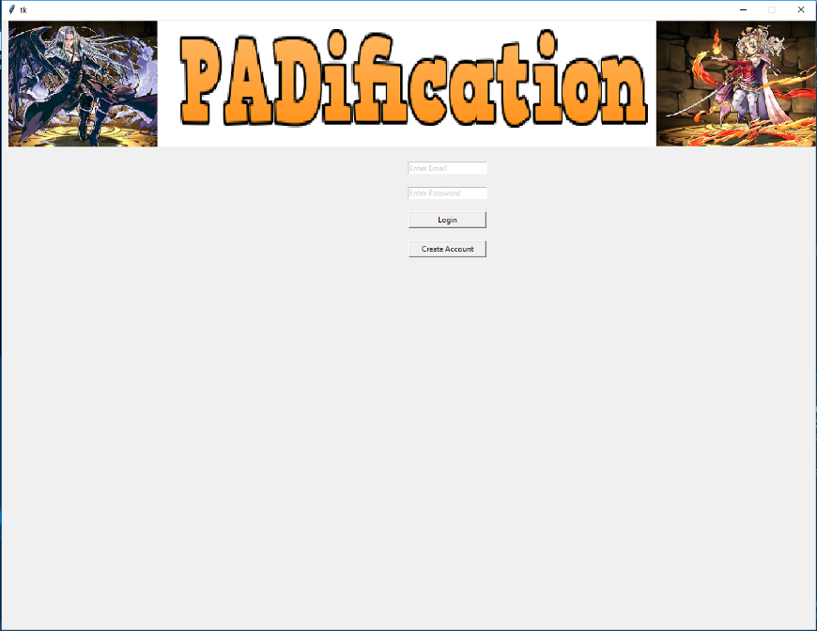

Figure 2.8‑1: PADification Login screen

The log in screen is the first screen to be displayed when users first execute the product. This screen serves as a security check for users as well as a primary way of differentiating each user by inputting unique combinations of credentials. This keeps the contents of PADification separate from each user so no overlap with each other’s information is encountered.

**Email & password fields**

These fields must be populated with not only existing information located in the PADification database, but the data inputted in each field must match the corresponding combination in the database in order to log in successfully. Any alterations will result in an unsuccessful login.

**Login button**

This button enables the check for appropriate login credentials. If both Email and password fields match a combination in the database, the user will proceed to that account’s information. If the data inputted in those two fields are invalid however, pressing the Login button will result in a message pop-up window stating invalid data has been inputted and the user will not be able to proceed.

**Create account button**

This button will send the user to the account creation screen.

### Account creation screen

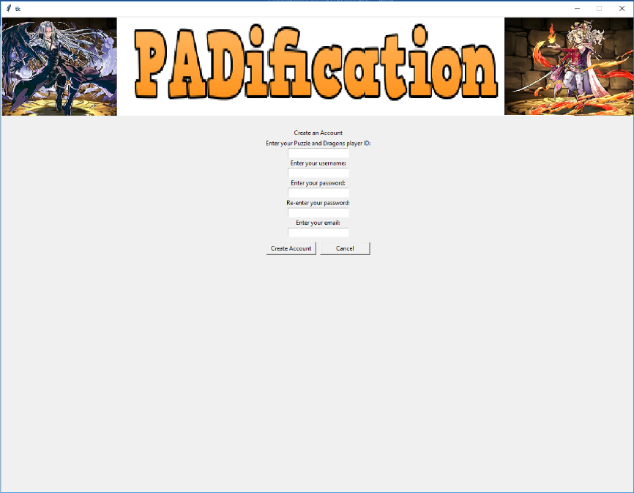

Figure 2.8‑2: PADification account creation screen

On this screen, user will be able to create an account for PADification so they may login and use the application.

**Account creation credentials**

In order to create an account, users must input data in each of the following fields;

* Player ID
* Username
* Password
* Confirm password
* Email

Player ID must be numeric content only and is a way to represent the user among everyone else. Username adds alphanumeric content in order to represent the user in any way they choose. Password and confirm Password are important as they are required to access an account when logging in. Both fields must be exactly the same in order to complete an account creation. Email is the last critical field as it is used in conjunction with password for logging in.

**Create account button**

This button will check all the inputted credentials. If all requirements are met, a new PADification account will be created and the user will be sent to the login screen where they will be able to input their email and password to log into their account and use the PADification product. If the credentials are not satisfactory, the account will not be created and a message popup window stating the fields are invalid.

**Cancel button**

This button will send the user back to the Login screen and undo any changes done to the account creation fields.

### Home screen

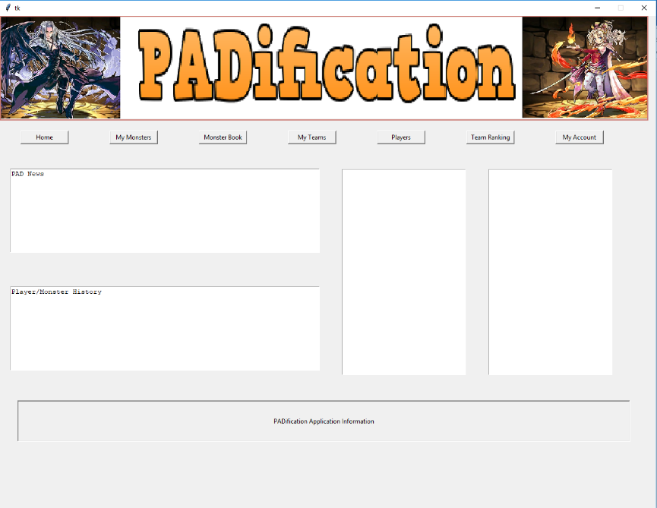

Figure 2.8‑3: PADification Home screen

The home screen is the first screen to load once a player has logged in. From the Home screen, a player will have access to buttons relating to every other major screen available within the product. These buttons are known as the Navigation buttons;

* Home screen
* Player collection
* Monster Book
* Edit Team
* Community
* Team Rank
* Account

The Navigation buttons are present on all major screens titled by the same names as the titles of the buttons listed prior.

**PADnews window**

The home screen offers windows for giving information about the current events or updates to the product.

**Follower & Following windows**

Players will also have access to a list of other players under the follower window as well as players whom the player is currently following in the following window. By selecting a player profile in one of these windows, the user will be sent to that player’s community information screen.

### Player collection

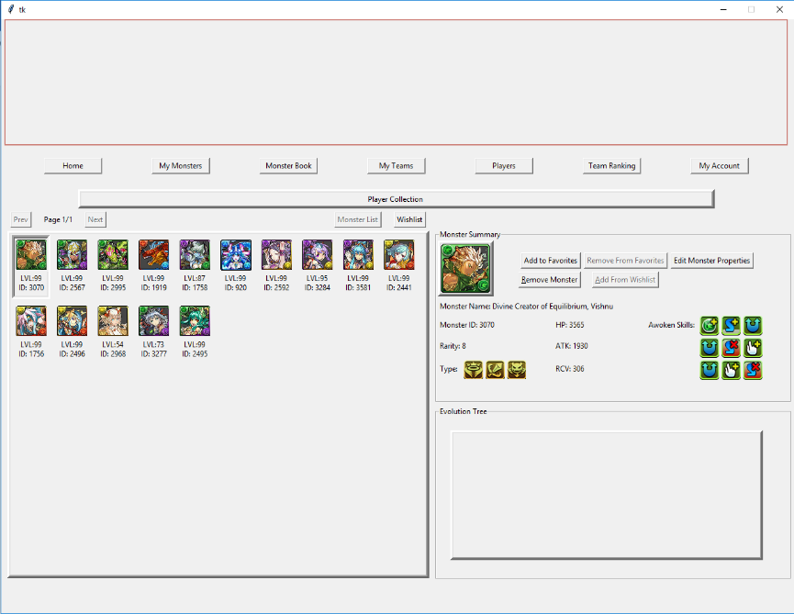

Figure 2.8‑4: PADification Player collection screen

The player collection screen is a major component of the PADification product. This screen contains a list of the instances of monsters added from the monster book screen by users. Selecting a monster will showcase that monster’s properties as well as a list of monsters relating to it by way of evolution or previous evolutions known as the evolution tree.

**Favorites/Add from Wishlist**

Depending on the specific monster selected, - this button will toggle between 2 purposes; enable/disable Favorites on a monster and adding a monster labelled as WishList monster to owned monster.

* As the **Favorites button**, it will give users the ability to set monsters under a “Favorite” label which will give them extra sorting properties as well as protect them from being deleted. When a Monster is already under the “Favorites” label, this button will serve as a way to undo the label and return the monster to an “owned” or simply a monster with no added sorting functionality.
* As the **Add from Wishlist button**, it will only be available when a monster has been added to the player collection from the monster book screen as a Wishlist monster meaning; a monster the player desires but has yet to obtain. This gives the monster a “Wishlist” label and by pressing this button, the monster will be changed to an “owned” status.

**Edit Monster properties**

This button will send the user to the edit monster screen.

**Remove/delete monster**

This button will allow a user to discard a monster from their list for whatever reason they may have. A prompt will appear when a user presses this button. This prompt will ask them to confirm the process before the monster can be deleted. Once a monster is deleted, its specific instance cannot be retrieved.

### Edit Monster screen

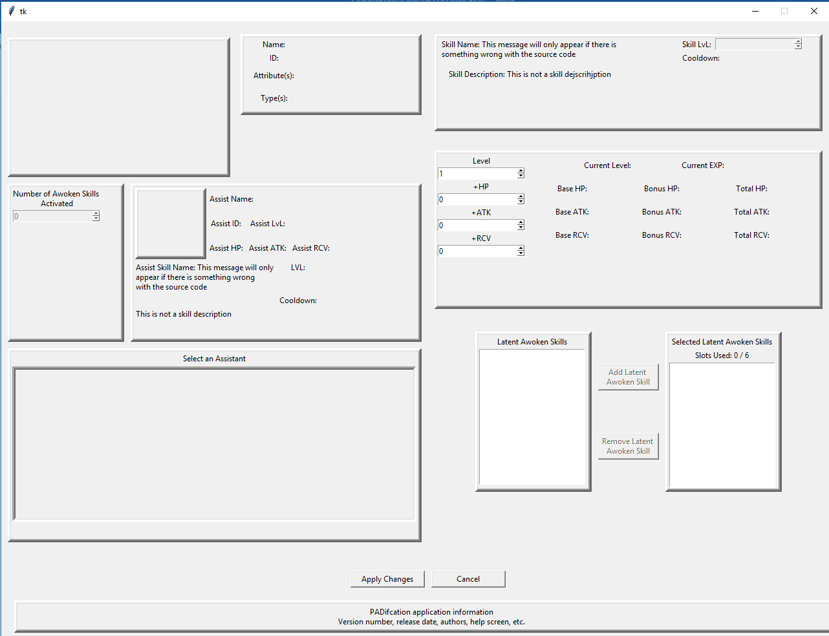

Figure 2.8‑5: PADification Edit monster screen

The edit monster screen allows users to not only view a monster’s properties, but to change them as they see fit. This screen offers users a view of the monster’s properties being;

* Name
* ID number
* Rarity
* Cost
* Active skill
* Leader skill
* Experience curve
* Coin value
* Monster points

The remaining properties of the monsters are available to be modified.

**Stats**

* Level: users can change the monster’s level from the monster’s minimum level to its maximum level.
* +HP: users can change the monster’s +HP stat from 0 to 99.
* +ATK: users can change the monster’s +ATK stat from 0 to 99.
* +RCV: users can change the monster’s +RCV stat from 0 to 99.

**Active Skill Level**

* Users can change a monster’s active skill level from its minimum level to its maximum level.

**Awoken Skills**

* Users can modify a monster’s list of Awoken skills. They will be able to decide how many Awoken skills will be awoken or not. (This feature will conform to the functionality of Puzzles and Dragons: Awoken skills can only be awoken in a linear fashion.)

**Latent Awoken Skills**

* Users can modify which Latent Awoken Skills are added to a monster within the limits of available slots. Users will also be able to activate the extra slot if they so choose.

**Assists**

* Users can modify the assist functions to a monster by using another monster from the user’s collection.

**Apply changes button**

* When a user performs changes to a monster, the changes will only be saved when a user presses this button. Otherwise the changes will be lost when a user changes screens or exits the product.

**Delete Monster button**

* This button will allow a user to discard a monster from their list for whatever reason they may have. A prompt will appear when a user selects this button. This prompt will ask them to confirm the process before the monster can be deleted. This process cannot be reverted.

**Return button**

* This button sends the user back to the player collection screen.

### Monster Book screen

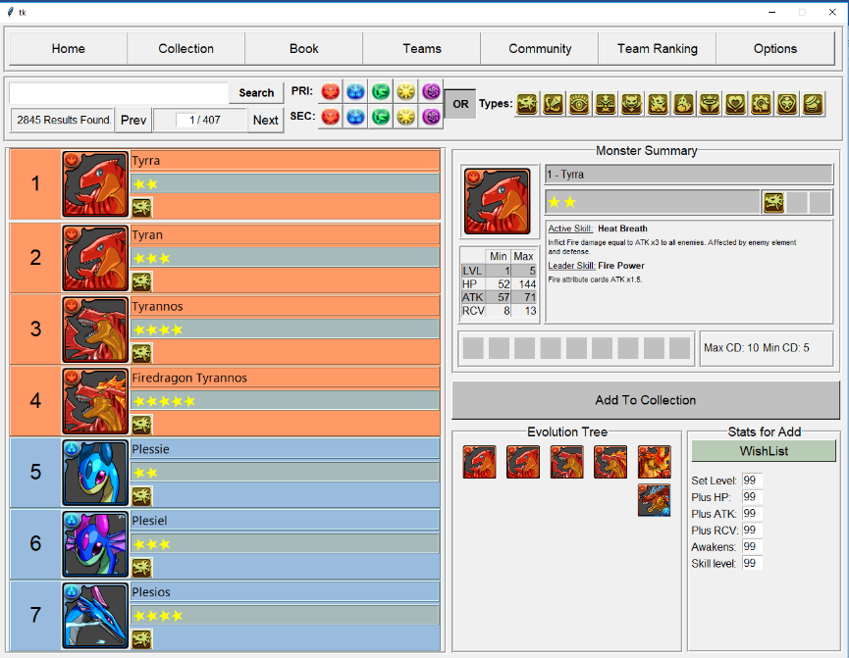

Figure 2.8‑6: PADification Monster book screen

The monster book screen allows users to view every monster available in the North American version of Puzzles and Dragons. The list contains interactable profiles of monsters. When a user selects a monster, that monster’s information will be displayed along with the evolution tree for the monster.

**Search bar**

Users can search for a specific monster by entering the monster’s name or ID number in the search bar and selecting the search button. Users also have access to a feature where they may input a specific page number in order to quickly jump to that page.

**Search filters**

Users have access to filters to help them search for specific monsters. They will be able to search by Attributes both primary and secondary as well as with the monster types.

**Hover features**

When a user hovers their cursor over icons such as monster type and awoken skills, a message will be displayed informing the user with the name of the specific icon they are hovering over. In addition, if a user hovers over the monster’s image, a larger fully detailed image will be displayed.

**Add monster to collection**

Users will be able to add the selected monster to their collection by clicking the “add monster to collection” button. This will send the selected monster to the collection under the “owned” label.

**Add monster to Wishlist**

Users will be able to add the selected monster to their collection by clicking the “add monster to collection” button. This will send the selected monster to the collection under the “Wishlist” label. In addition to adding a monster to the player collection, users will have access to a few properties to modify before adding the monster. These are the modifiable fields:

* Level
* +HP
* +ATK
* +RCV
* Awoken Skills awoken
* Active skill level

### My Teams screen

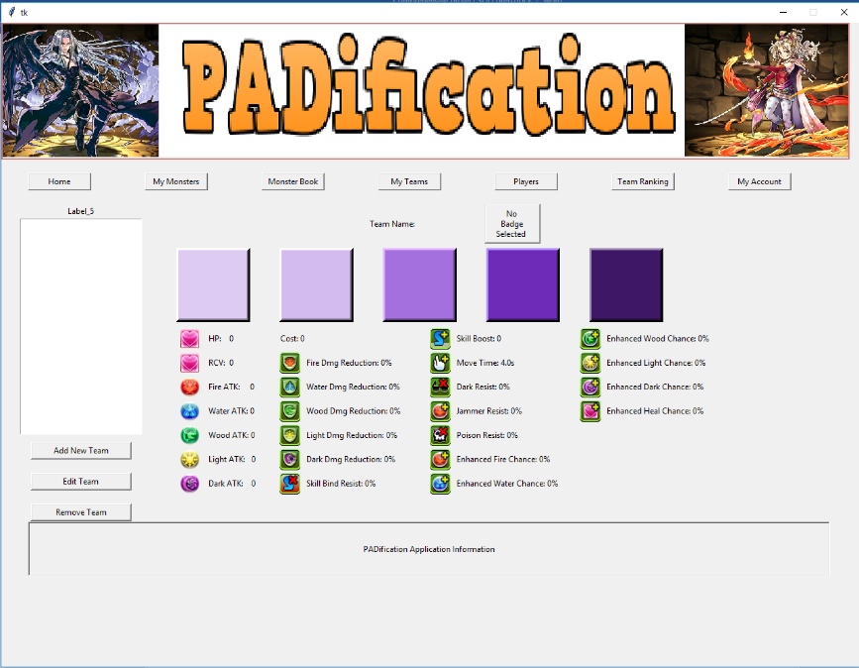

Figure 2.8‑7: PADification My teams screen

The My Teams screen allows users to set the monsters in their collections into teams. Users can view a team’s properties and the calculated stats of these properties based on the monster instances they’ve added to a given team.

**Cycle through teams**

Users have the ability to create numerous teams. Each team will be added to a list where users can select individual teams which will display their information. Selecting a team will also dictate the team which will be affected when users wish to Edit or delete a team.

**Create new team button**

This will send the user to a blank version of the edit team screen.

**Edit team button**

This will send the user to the edit team screen. The specific team will be determined by the team currently selected in the list.

**Delete team button**

This will remove the selected team from the user’s list permanently. When clicking the delete button a prompt will appear asking the user to confirm or deny the deletion of their team.

### Edit team screen

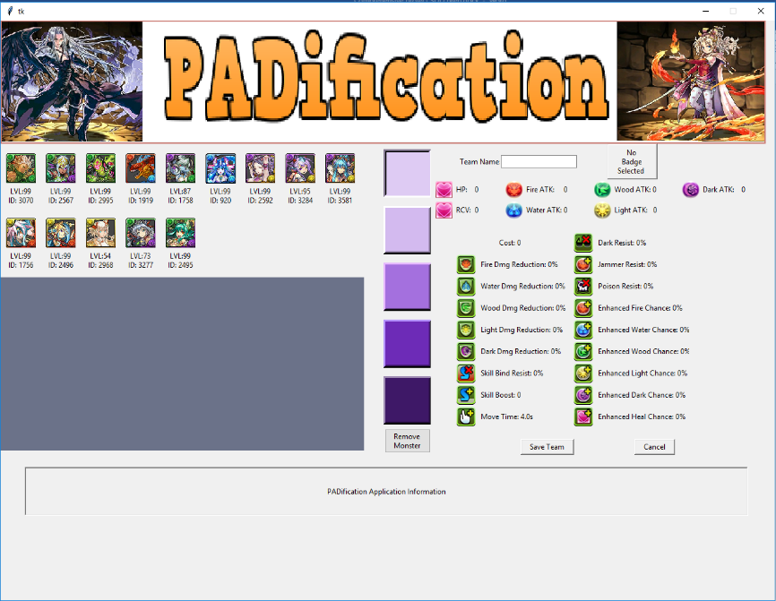

Figure 2.8‑8: PADification Edit team screen

The edit team screen allows users to mold teams, using the monsters from their collection, into any combination they wish.

**Team slots**

Users can select each of the 5 slots found on any team. When a slot is selected, users can then select a monster from their list. This will populate the slot with the monster selected and later the team’s properties. Users can also select the remove monster option to remove any instances in a slot. The same monster instance cannot be applied more than once in a single team.

**Team name**

Users are able to change a team’s name by inputting alphanumeric content in the Team name field.

**AwokenBadge button**

Users can choose to add an Awoken badge to their teams. Selecting this option will provide the user with a list of Awoken badges as well as an option to remove one if they so choose.

**Save Team button**

This button will save any changes done to a team. This button is also used to save a team instance when creating a new team.

**Delete team button**

This will remove the team from the user’s list permanently. When clicking the delete button a prompt will appear asking the user to confirm or deny the deletion of their team.

**Submit/retract team**

Users can submit the teams they create in order to have them available to the world and be given judgement. This judgement will declare the rank a team receives. This will help the community express how they feel about a given team. When a team has already been submitted, the button will become an unsub button. When pressed, the user will be prompted and informed that retracting a team will result in the loss of all ranks and the user will be asked to confirm or deny the retraction.

### Community screen

### Team Ranking screen

### Account information screen

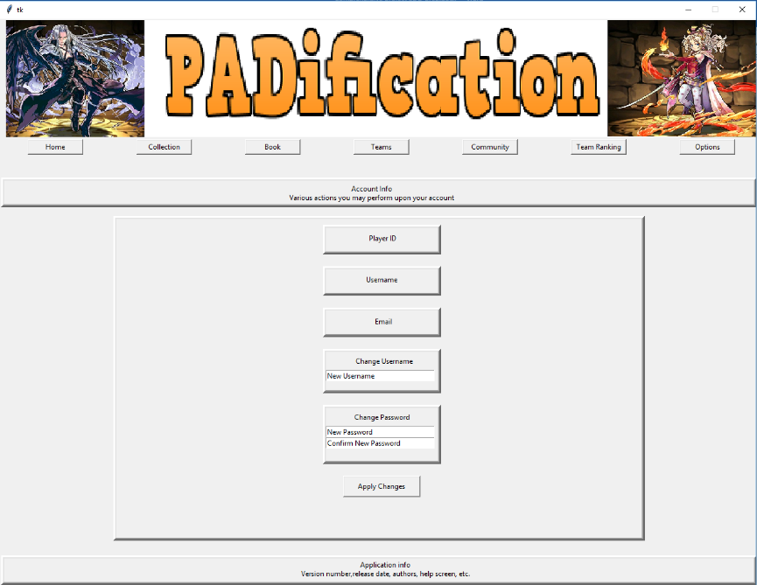

Figure 2.8‑9: PADification Account screen

The account information screen provides users with all the information about their account. These being:

* Player ID
* Email
* Password
* Username
* ProfileImage

Users are able to change their username, playerID, password and profile image here.

**Apply Changes button**

When users select this button, any changes that have been done to the modifiable fields will be saved. In the case of changing passwords, users will need to enter the new password and confirm the new password. If a user fails to match both password and confirm password fields, the changes will not be saved.

## Structure Viewpoint

## Interactions Viewpoint

## State Dynamics Viewpoint

## Algorithm Viewpoint

## Resources

# Appendices

## Tool Configuration

### Configure MSSQL DB for Remote Connections.

#### Purpose

Allowing MSSQL 2014 servers to Accept TCP/IP connections and SQL authentication.

#### Prerequisites

* MSSQL 2014 Installed
* Microsoft SQL Server Management Tool

#### Enable TCP/IP Connection

To enable the TCP/IP protocol in SQL Server 2014, follow these steps:

1. Open **SQL Server Configuration Manager** from:

for 64 bits: "**C:\Windows\SysWOW64\SQLServerManager12.msc**"

for 32 bits: "**C:\Windows\system32\SQLServerManager12.msc**"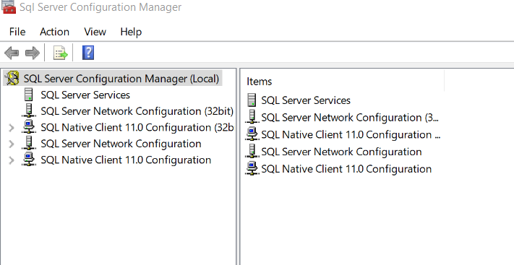

Figure 3.1‑1: Open SQL server Configuration

1. Expand **SQL Server Network Configuration** and click on **Protocols for MSSQLSERVER**

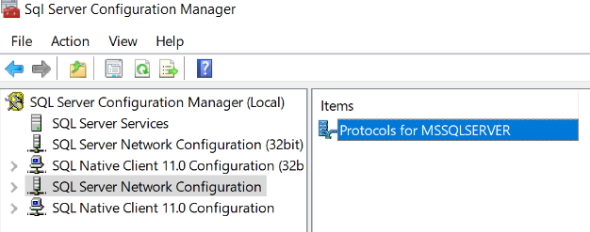

Figure 3.1‑2: SQL server configuration; Protocols for MSSQLSERVER

1. Right click on **TCP/IP** and choose **Enable**

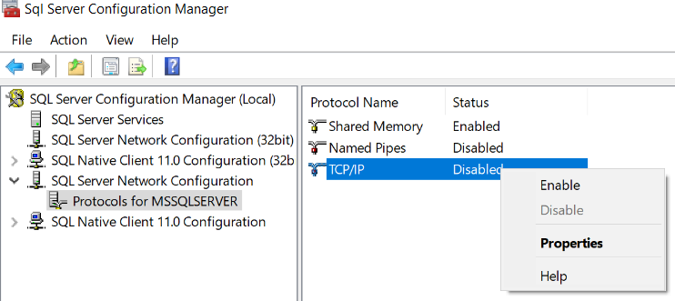

Figure 3.1‑3: SQL server Configuration Enable TCP/TP

1. Click **OK** on the Warning that the service will have to be restarted
2. Click on **SQL Server Services**

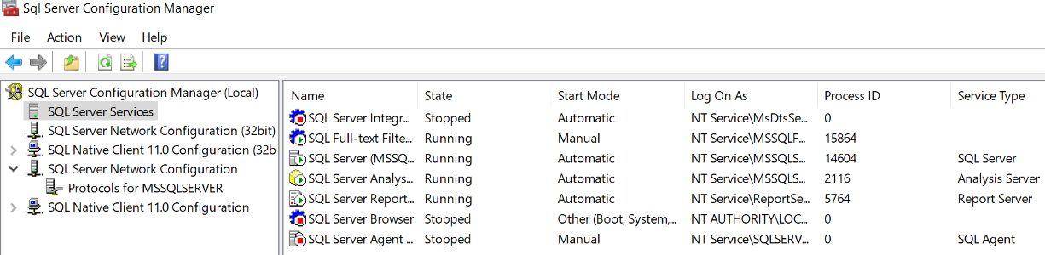

Figure 3.1‑4: SQL server Configuration Server services

1. Right click on **SQL Server (MSSQLSERVER)** and choose **Restart**

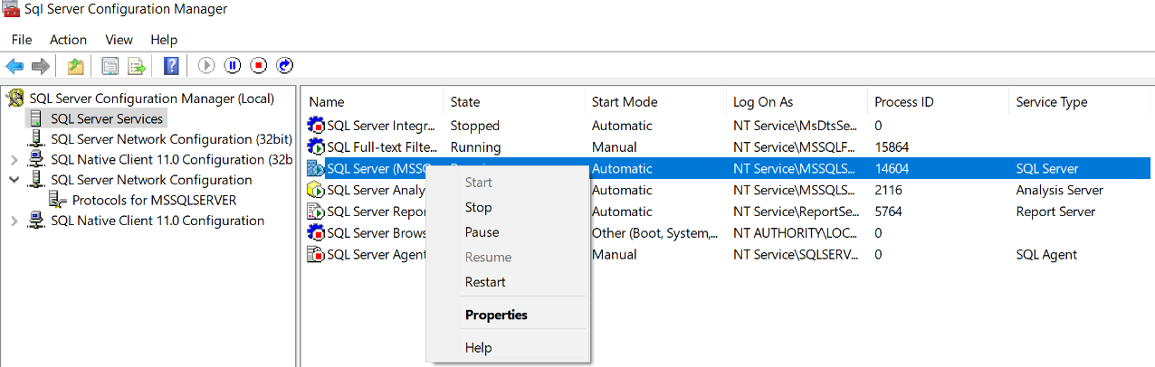

Figure 3.1‑5: SQL server Configuration restart MSSQLSERVER

#### Setup User for SQL TCP/IP Connection

To create a username to access the SQL Server Via TCP/IP:

1. Open **SQL Server Management Studio** and **Login**.
2. Expand **Security** in the **Object Explorer**.
3. Right Click **Logins** and Select **New Login**.

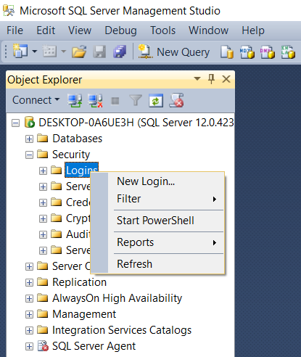

Figure 3.1‑6: MSSQL SMS New log in

1. In the Login Creation Screen first select **SQL Server Authentication**.

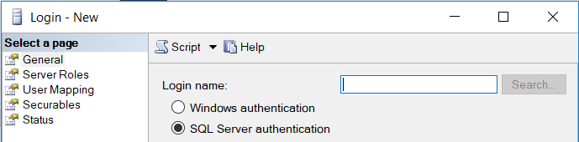

Figure 3.1‑7: MSSQL SMS New log in SQL Server Authentication

1. Enter the New **Login Name** and **Password / Confirm Password**.
2. Uncheck **Enforce Password Policy**.

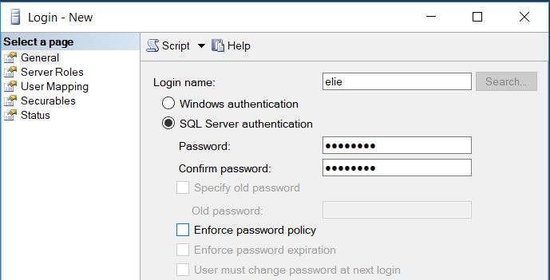

Figure 3.1‑8: MSSQL SMS New log in name/password/Enforce Password Policy

1. Select **Server Roles** at the top left.

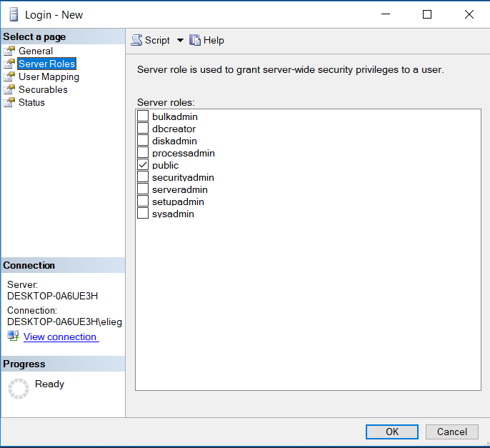

Figure 3.1‑9: MSSQL SMS New log in Server Roles

1. Select the role **SysAdmin**. "If more constraints are needed, creating custom Roles is possible."
2. Click **OK**

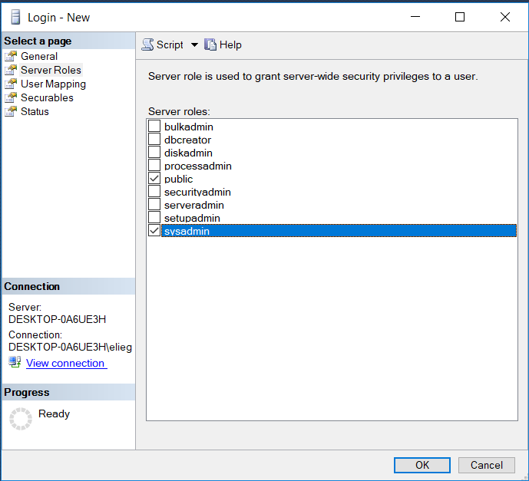

Figure 3.1‑10: MSSQL SMS New log in Server Roles SysAdmin

1. Right Click on **server** in **Object** **Explorer** *first item* and Select **Properties**

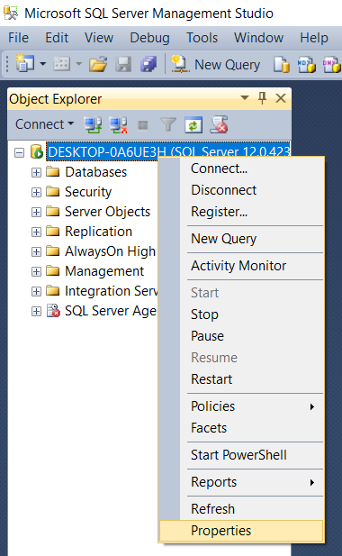

Figure 3.1‑11: MSSQL SMS Server Properties

1. Select **Security** on the left

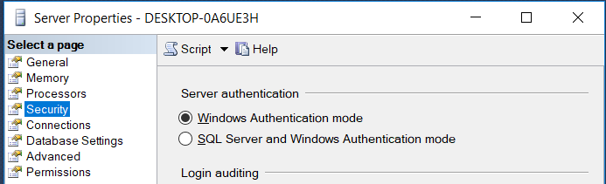

Figure 3.1‑12: MSSQL SMS Server properties Security

1. Select **SQL and Windows Authentication Mode** and Press **ok**

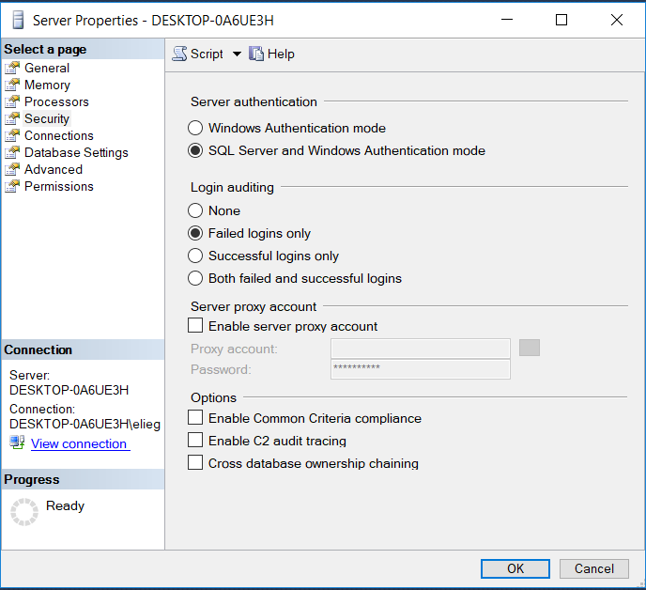

Figure 3.1‑13: MSSQL SMS Server Properties SQL Server and Windows Authentication mode

1. Restart the SQL server.

#### Setup Firewall Exceptions:

To allow connection through the Windows Firewall

1. Open **Windows Firewall**

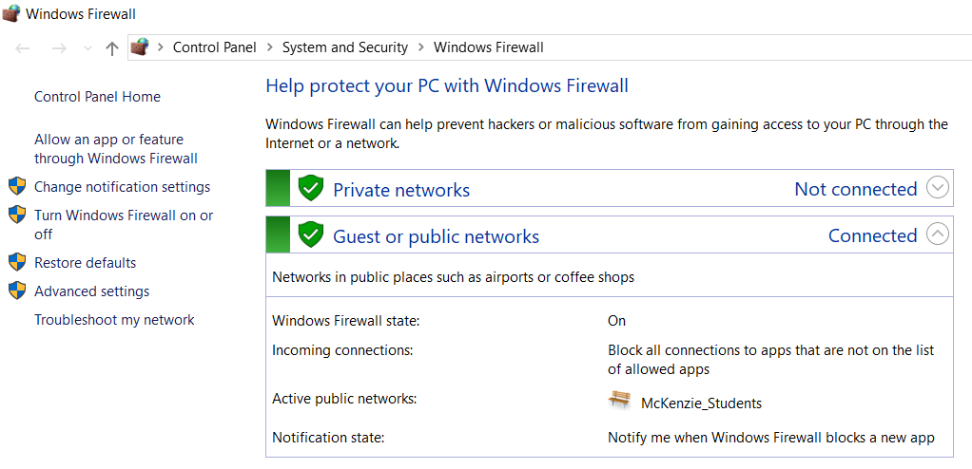

Figure 3.1‑14: Windows Firewall

1. Select **Advanced settings** on the left.

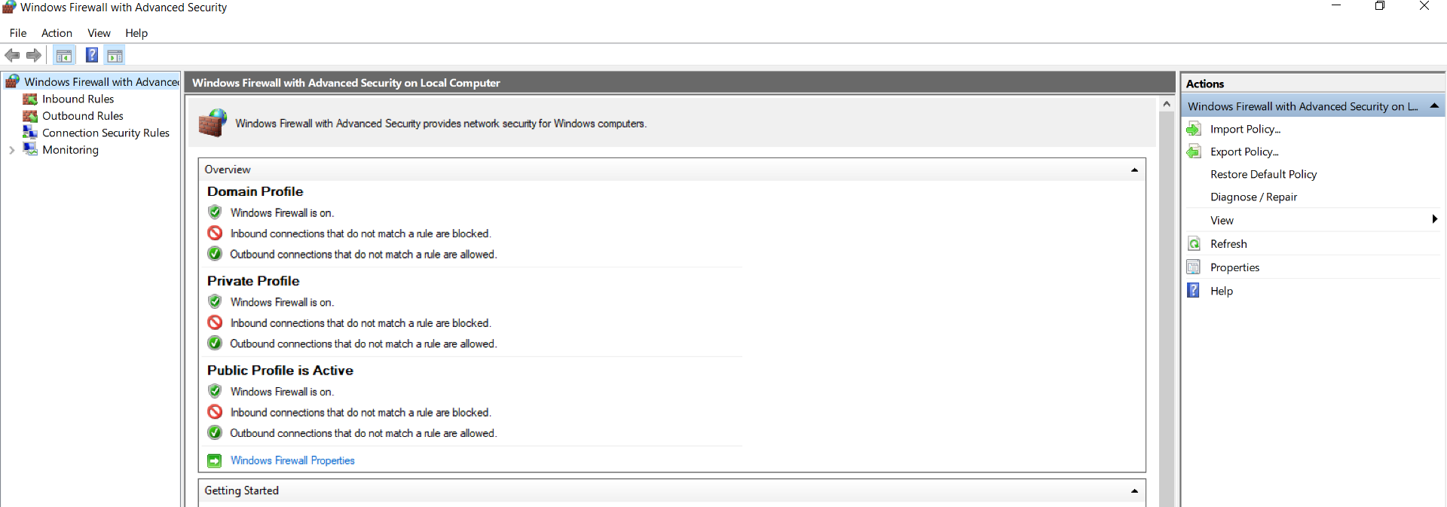

Figure 3.1‑15: Windows Firewall Advanced settings

1. Select **Inbound Rules** on the Left.

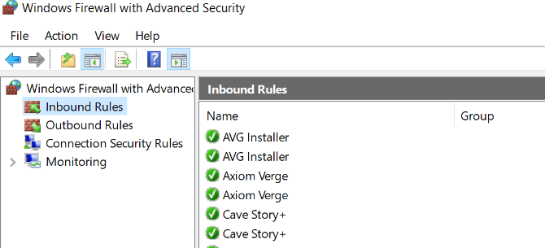

Figure 3.1‑16: Windows Firewall Inbound Rules

1. Select **New Rule** on the Right.

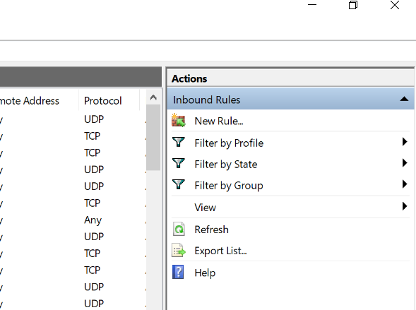

Figure 3.1‑17: Windows Firewall Inbound Rules/New Rules

1. Select **Port** and hit **Next >**

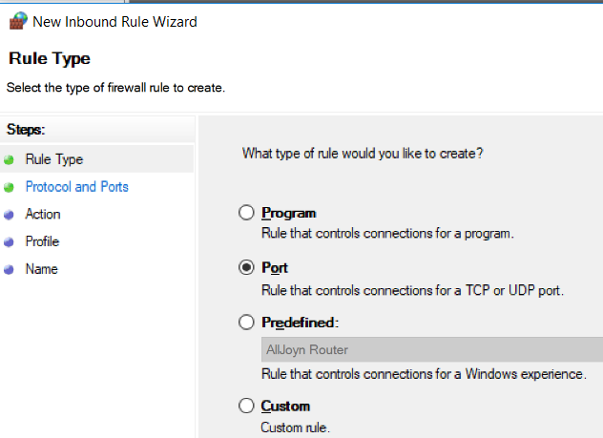

Figure 3.1‑18: Windows Firewall Inbound Rules/New Rules/Port

1. Set **Specific Local Ports** to **1433** and hit Select **Next >**

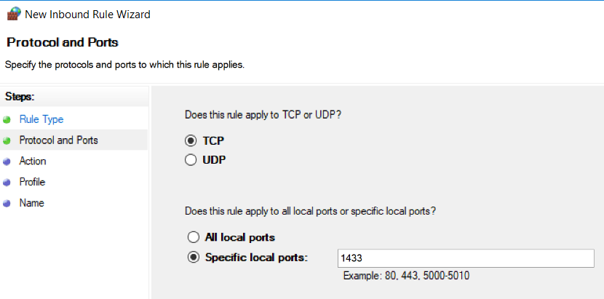

Figure 3.1‑19: Windows Firewall Inbound Rules/New Rules/Specified local port

1. Select **Allow the connection** and hit **Next >**

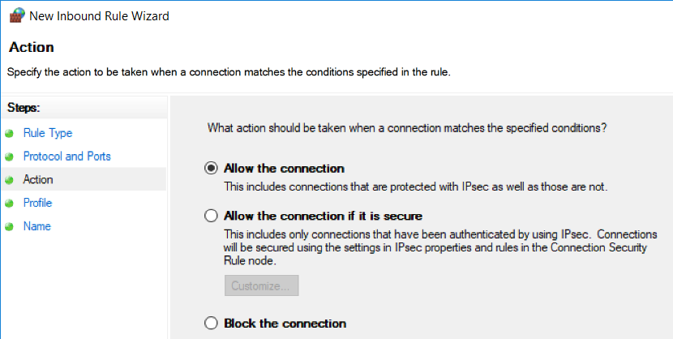

Figure 3.1‑20: Windows Firewall Inbound Rules/New Rules/Allow connection

1. Select all check boxes and hit **Next >**

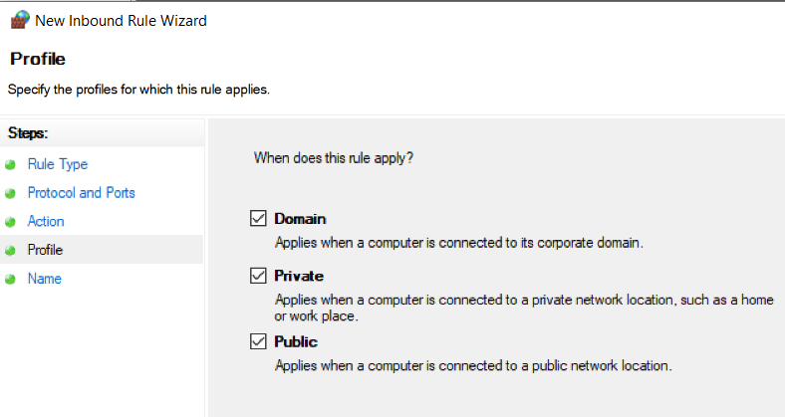

Figure 3.1‑21: Windows Firewall Inbound Rules/New Rules/Profile

1. Name **SQL IN** and hit **Finish**

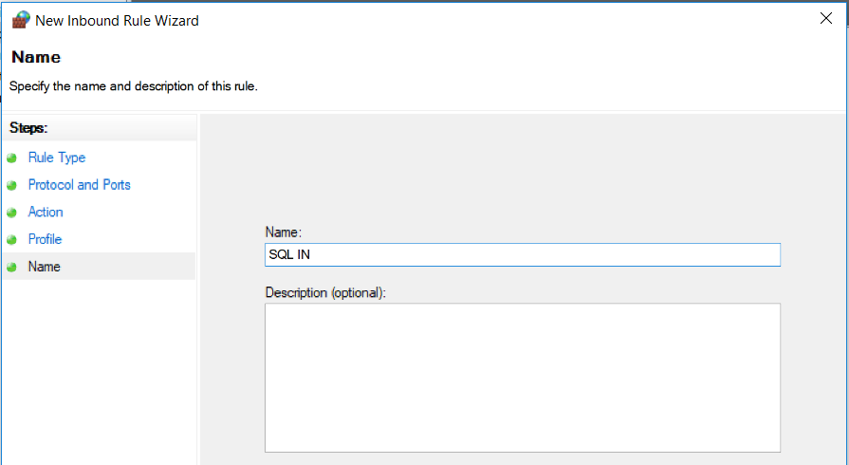

Figure 3.1‑22: Windows Firewall Inbound Rules/New Rules/Name

1. Select **Outbound Rules** on the Left.

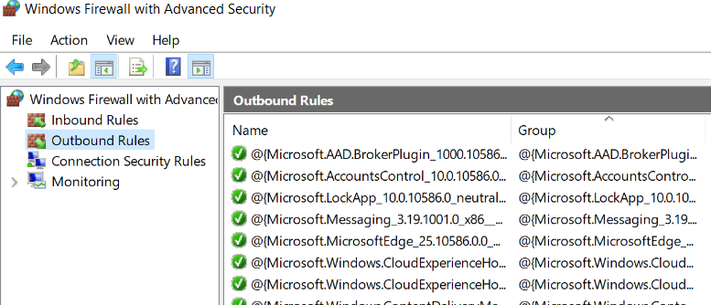

Figure 3.1‑23: Windows Firewall Outbound Rules

1. Select **New Rule** on the Right.

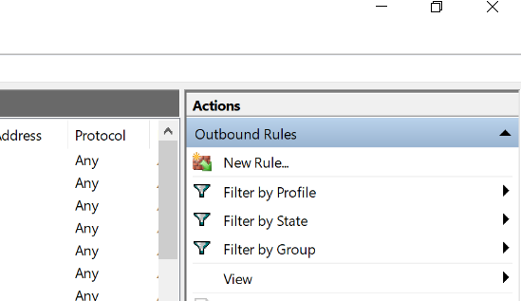

Figure 3.1‑24: Windows Firewall Outbound Rules/New Rules

1. Select **Port** and hit **Next >**

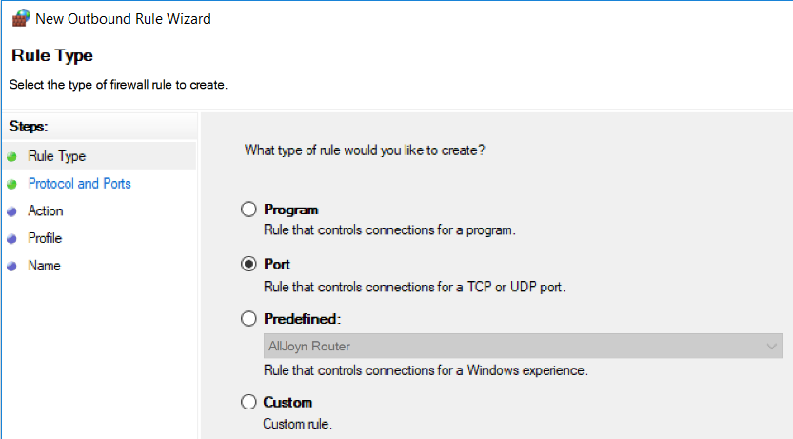

Figure 3.1‑25: Windows Firewall Outbound Rules/New Rules/Port

1. Set **Specific Remote Ports** to **1433** and hit Select **Next >**

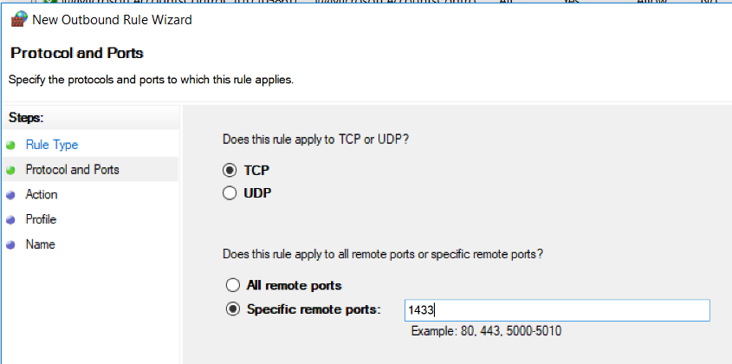

Figure 3.1‑26: Windows Firewall Outbound Rules/New Rules/Specific remote ports

1. Select **Allow the connection** and hit **Next >**

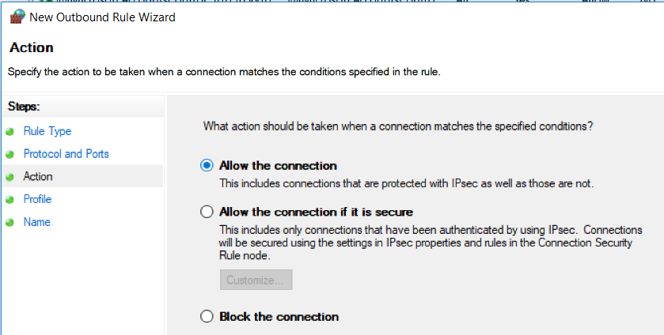

Figure 3.1‑27: Windows Firewall Outbound Rules/New Rules/Allow connection

1. Select all check boxes and hit **Next >**

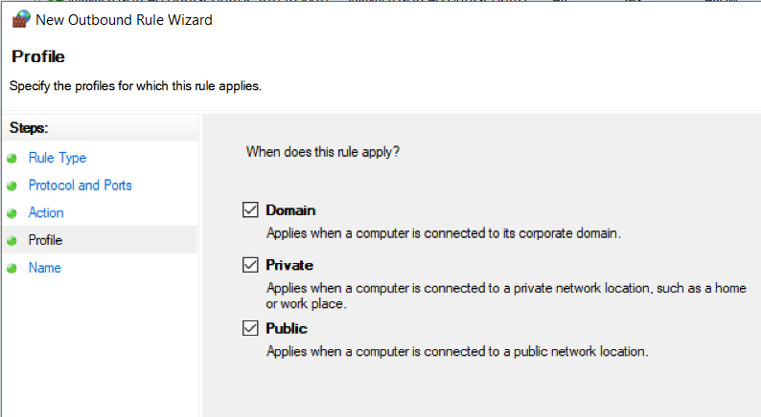

Figure 3.1‑28: Windows Firewall Outbound Rules/New Rules/Profile

1. Name **SQL OUT** and hit **Finish**

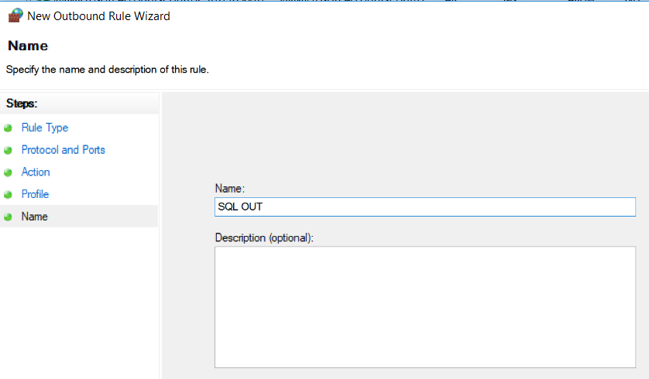

Figure 3.1‑29: Windows Firewall Outbound Rules/New Rules/Name

### Create the Database from .bat files

#### Prerequisites:

* Microsoft SQL server management studios
* Install Microsoft ODBC 13.1
* Install SQLCMD utilities

#### Install Microsoft ODBC 13.1

1. Search for SQLCMD Utilities 13.1 or use the link below to reach the website and hit **Download.** <https://www.microsoft.com/en-us/download/details.aspx?id=53339> 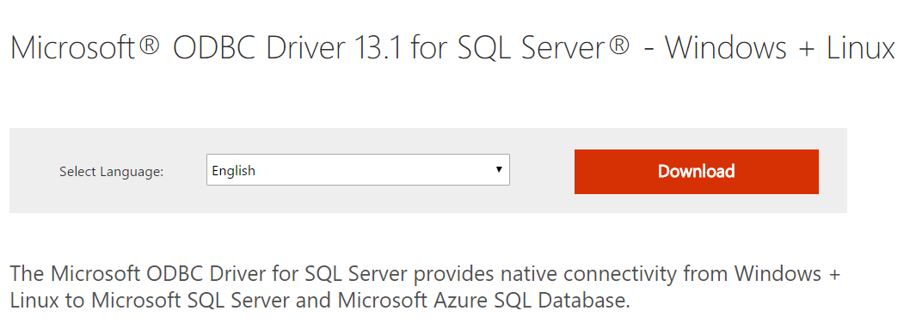

Figure 3.1‑30: Download Screen

1. Check the 2nd box titled: **x64\msodbcsql.msi** and hit Next. 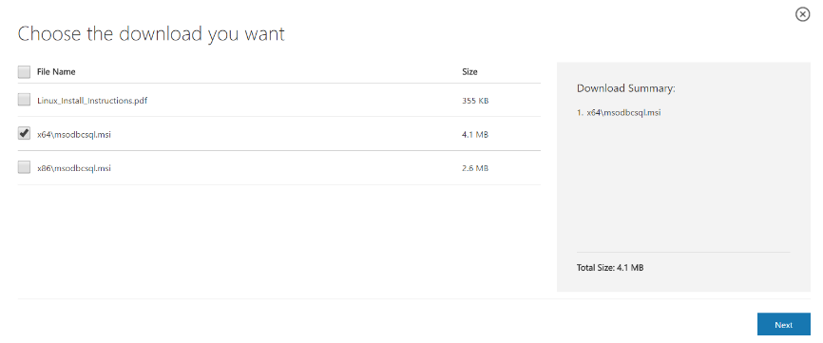

Figure 3.1‑31: ODBC Select Download

1. Proceed to install the application.
   * **Warning:** your PC will have to restart after the changes have been made.

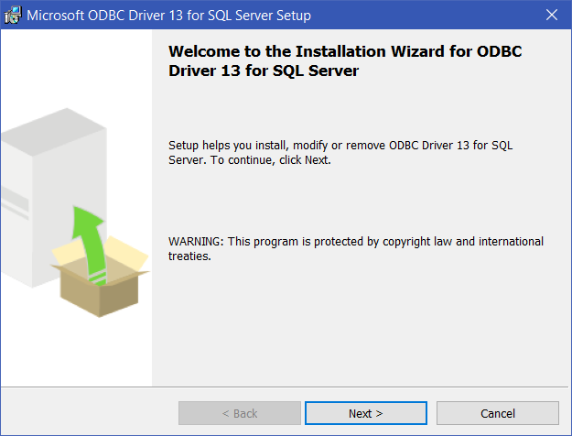

Figure 3.1‑32: ODBC 1st Screen of Install

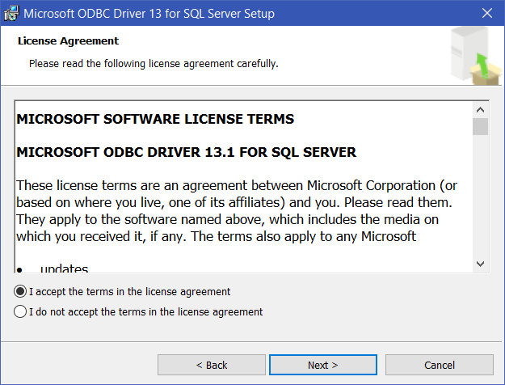

Figure 3.1‑33: OBDC License Agreement

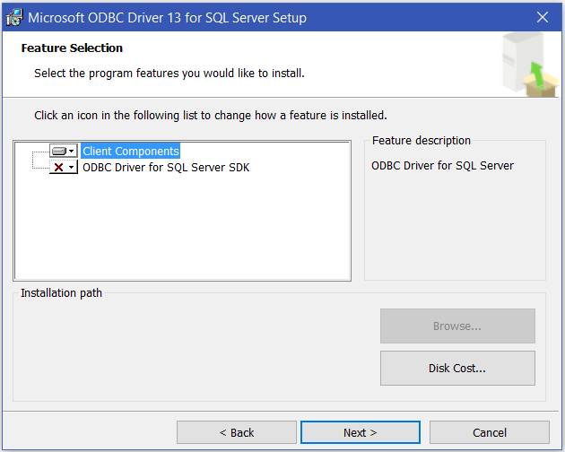

Figure 3.1‑34: ODBC Feature Selection

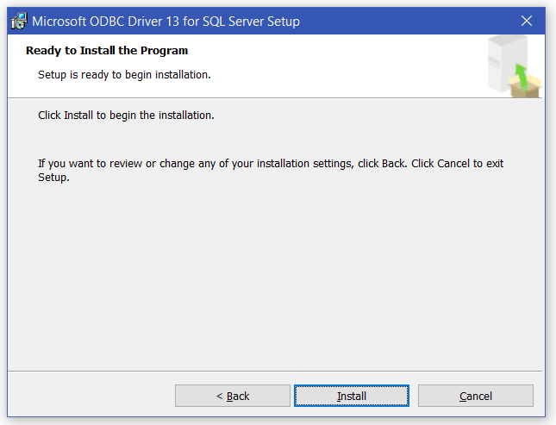

Figure 3.1‑35: ODBC Begin Installation

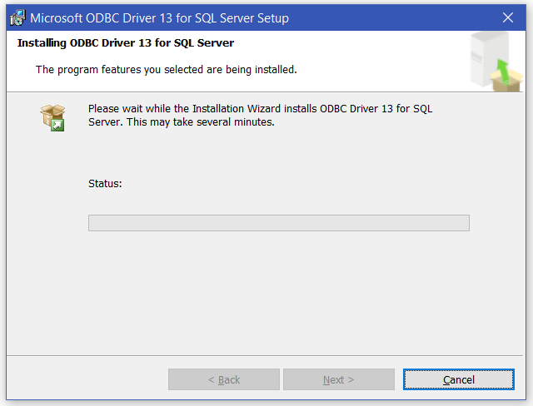

Figure 3.1‑36: ODBC Install Screen

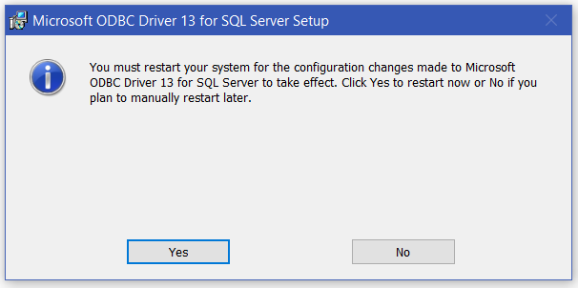

Figure 3.1‑37: Notification of Restart

#### Install SQLCMD utilities

1. Search for SQLCMD Utilities 13.1 or use the link below to reach the website and hit **Download.** <https://www.microsoft.com/en-us/download/details.aspx?id=53591>

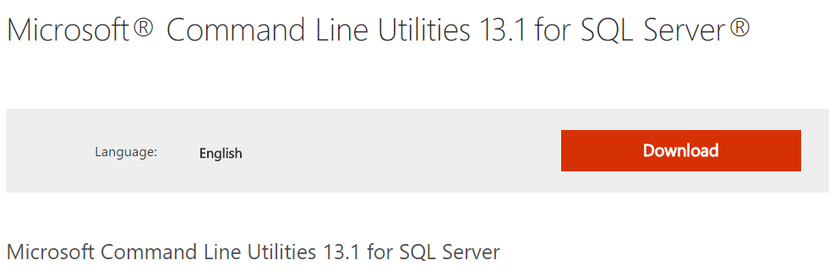

Figure 3.1‑38: SQLCMD Download Page

1. Check the 2nd box titled: **Command Line Utilities MSI files\x86\MsSqlCmdLnUtils.msi** and hit Next.

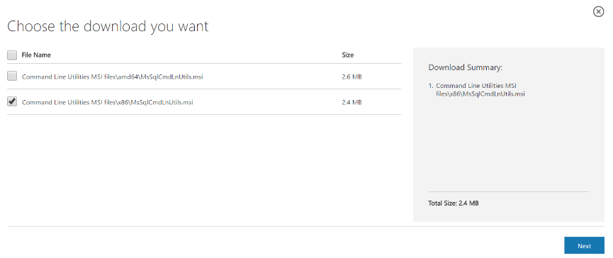

Figure 3.1‑39: SQLCMD Choose Download

1. Proceed to install the application.

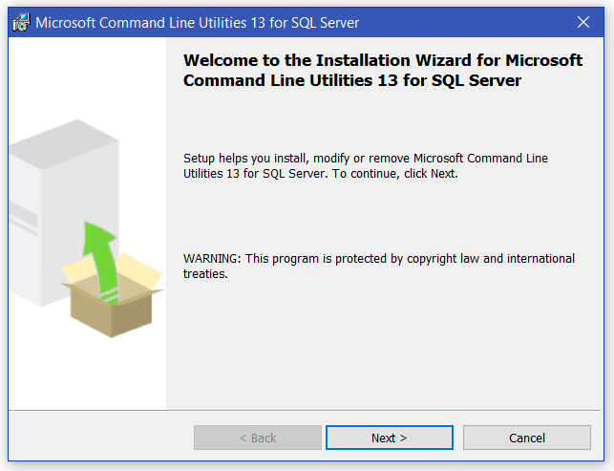

Figure 3.1‑40: SQLCMD First Page of Installation

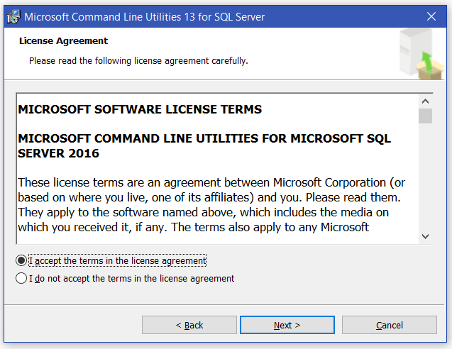

Figure 3.1‑41: SQLCMD Accept License Terms

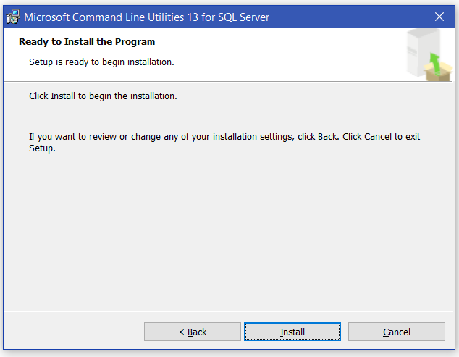

Figure 3.1‑42: SQLCMD Confirm Installation

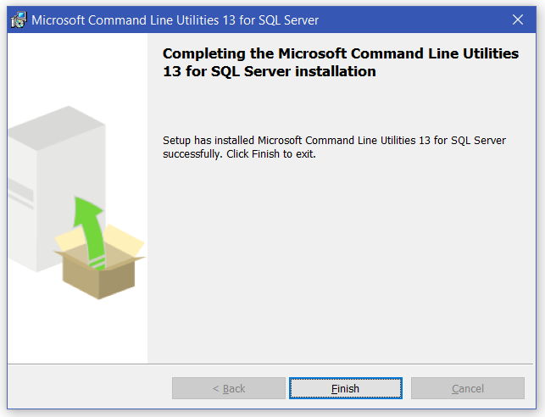

Figure 3.1‑43: SQLCMD Finish Installation

#### Create The database

1. Find the **Create_DB.bat** file on your PC
2. Ensure the following files are located within the same directory as **Create_DB.bat**
   * Generate-PADification-DB.sql
   * Table-Create.sql
   * LatentSkill-Inserts.sql
   * AttributeAndType-Inserts.sql
   * ActiveSkill-Inserts.sql
   * LeaderSkill-Inserts.sql
   * AwokenSkill-Inserts.sql
   * AwokenSkillList-Inserts.sql
   * MonsterClass-Inserts.sql
   * EvolutionTree-Inserts.sql
   * AwokenBadges-Inserts.sql
3. **Double click** the file and the process will begin automatically.
4. **Press the Return key** when prompted to continue the process.

#### Delete The database

**NOTE**: In order to delete the database, you must ensure the following

* + Close any .sql files associated to the PADification database
  + Refresh the database

1. Find the **Drop_DB.bat** file on your PC
2. Ensure the following file is located within the same directory as **Drop_DB.bat**
   * Drop-PADification-DB.sql
3. **Double Click** the file and the process will begin automatically
4. **Press the Return Key** when prompted to continue the process.